RV COLLEGE OF ENGINEERING®, BENGALURU-560059

(Autonomous Institution Affiliated to VTU, Belagavi)

**DEPARTMENT OF COMPUTER SCIENCE AND ENGINEERING**



**BLOOD BANK MANAGEMENT SYSTEM**

***Submitted by***

|  |  |
| --- | --- |
| **MOHITH S** | **1RV22CS119** |
| **MANOJ KUMAR B V** | **1RV23CS407** |
| **NAGAPRASAD NAIK** | **1RV23CS410** |
|  |  |

***in partial fulfillment for the requirement of 5th Semester***

***Database Management Systems Laboratory Mini Project (CD252IA)***

**Under the Guidance of**

**Dr. Suma B**

**Associate Professor**

**COMPUTER SCINECE AND ENGINEERING**

**RV COLLEGE OF ENGINEERING**

**Academic Year 2024-25**

RV COLLEGE OF ENGINEERING®, BENGALURU - 560059

**(Autonomous Institution Affiliated to VTU, Belagavi)**

**DEPARTMENT OF COMPUTER SCIENCE AND ENGINEERING**

**CERTIFICATE**

Certified that the project work titled **‘BLOOD BANK MANAGEMENT SYSTEM’** is carried out by **MOHITH S (1RV22CS119), MANOJ KUMAR B V (1RV23CS407), NAGAPRASAD NAIK (1RV23CS410),** who are bonafide students of RV College of Engineering®, Bengaluru, in partial fulfillment of the curriculum requirement of 5th Semester DATABASE MANAGEMENT SYSTEMS (CD252IA) during the academic year **2024-2025**. It is certified that all corrections/suggestions indicated for the internal Assessment have been incorporated in the report deposited in the departmental library. The report has been approved as it satisfies the academic requirements in all respect laboratory mini-project work prescribed by the institution.

**Signature of Faculty In-charge Head of the Department**

**Dept. of CSE, RVCE**

**External Examination**

|  |  |
| --- | --- |
| **Name of the Examiners** | **Signature with Date** |
|  |  |
|  |  |

**ACKNOWLEDGEMENT**

Any achievement, be it scholastic or otherwise does not depend solely on the individual efforts but on the guidance, encouragement and cooperation of intellectuals, elders and friends. A number of personalities, in their own capacities have helped me in carrying out this project work. I would like to take this opportunity to thank them all.

We deeply express our sincere gratitude to my guide **Dr. Suma B, Associate Professor,** Department of CSE, RVCE, Bengaluru,for her able guidance, regular source of encouragement and assistance throughout this project

We would also like to thank **Dr. Shantha Rangaswamy, Head of Department**, Computer Science & Engineering, RVCE, Bengaluru, for her valuable suggestions and expert advice.

Moreover, I would like to thank **Dr. Subramanya. K. N**, **Principal**, RVCE, Bengaluru, for his support towards completing the project work.

We thank our Parents, and all the faculty members of Department of Computer Science & Engineering for their constant support and encouragement.

**ABSTRACT**

A **Blood Bank Management System** serves as a sophisticated software solution that monitors and manages various aspects of blood banking process. It includes complex functionalities such as maintaining a detailed record of donor information, identifying the doctor responsible for blood collection, recording specific blood specifications, and documenting details about receivers who receive blood from the bank. The existing system follows a modular structure with modules for donor management, blood collection and testing, inventory management, receiver information, and reporting. These systems streamline operations, ensuring accurate record-keeping, and coordination between donors, receivers, and medical staff.

The proposed system introduces key enhancements. It includes features such as providing information on the contents of a particular blood selected from the blood bank, generating bills for blood donations, and documenting details of the donor’s health at the time of donation for future reference. These additional functionalities not only improve the efficiency of blood bank operations but also contribute to better resource management and the overall safety of blood transfusions. The blood bank management system is expected to yield significant results, including improved inventory management, reduced wastage of blood products, and enhanced donor participation rates. It will enable real-time tracking of blood donations and integration of donor health information to ensure the safety and suitability of blood products.

Overall, the system is poised to streamline processes, facilitate better communication, and ultimately contribute to improved receiver outcomes through efficient blood resource management.

**Table of Contents**

|  |  |
| --- | --- |
|  | Page  No: |
| Acknowledgement | i |
| Abstract | ii |
| Table of Contents | iii |
| List of Figures | iv |
|  |  |
| 1. Introduction | 1 |
| * 1. Objective | 2 |
| * 1. Scope | 2 |
| 1. Software Requirement Specification | 3 |
| * 1. Software Requirements | 3 |
| * 1. Hardware Requirements | 3 |
| * 1. Functional Requirements | 4 |
| 1. Entity Relationship Diagram | 5 |
| * 1. Entities | 5 |
| * 1. Relationships | 5 |
| * 1. Attributes | 6 |
| * 1. Flow of Information | 6 |
| 1. Detailed Design | 8 |
| * 1. DFD Level 0 | 8 |
| * 1. DFD Level 1 | 9-10 |
| 1. Relational Schema and Normalization | 11-15 |
| 1. NoSQL | 16 |
| 1. Conclusion & Future Enhancements | 17-18 |
| 1. References | 19 |
| 1. Appendix | 20-22 |

**List of Figures**

|  |  |  |
| --- | --- | --- |
| Figure No. | Figure Name | Page  No: |
| 3.1 | ER Diagram | 7 |
| 4.1 | DFD Level 0 | 8 |
| 4.2 | DFD Level 1 | 9 |
| 5.1 | Relational Schema Diagram | 11 |
| 5.2 | Sample Doctor Data | 12 |
| 5.3 | 2NF | 13 |
| 5.4 | 3NF | 14 |
| 9.1 | Home Page | 20 |
| 9.2 | Donor Registration | 20 |
| 9.3 | Receiver Details | 21 |
| 9.4 | Admin Page | 21 |
| 9.5 | Summarized Donor Details in MongoDB | 22 |

**Chapter 1**

**INTRODUCTION**

The Blood Bank Management System is a comprehensive and advanced software platform designed to revolutionize the processes of blood banking by ensuring precision, efficiency, and safety in operations. Blood banks form a critical backbone of healthcare infrastructure, serving as a crucial link between voluntary donors and patients requiring life-saving transfusions. However, the increasing demand for blood units, coupled with the complexities of inventory management, donor health tracking, and compliance with safety standards, necessitates the adoption of robust systems that address these challenges effectively.

This system provides a range of essential functionalities that enhance the management of blood bank operations. It maintains detailed records of donors, including their personal details, blood types, and donation history, and associates each donation with a unique doctor overseeing the collection process. Furthermore, the system captures diagnostic health information at the time of donation, enabling informed decision-making and ensuring that the collected blood meets safety standards. Key operational processes, such as blood testing, inventory tracking, and recipient documentation, are streamlined to improve transparency and reduce manual errors. By centralizing all these processes within an integrated platform, the system ensures optimal utilization of resources and minimizes wastage, thus contributing to better healthcare outcomes.

In addition to its operational benefits, the Blood Bank Management System leverages cutting-edge technologies to enhance data analysis, reporting, and decision-making. A significant aspect of the system is its integration of advanced natural language processing (NLP) tools and machine learning models. The NLP capabilities include generating detailed blood donation and inventory reports, summarizing donor and patient interactions, and ensuring clear and concise communication among stakeholders. Specifically, the system incorporates **mdizak/text-summarizer-bart-large-cnn-samsum-rust**, a high-performance summarization model based on BART architecture fine-tuned for conversational data. This integration enables the system to generate concise yet informative summaries of donor health records and operational reports, reducing the cognitive load on medical staff and facilitating quick decision-making.

By combining traditional database management systems with modern advancements like NoSQL, NLP, and machine learning, the Blood Bank Management System addresses both current and emerging challenges in blood bank operations. It serves not only as a tool for efficient management but also as a transformative solution that enhances transparency, safety, and trust in the critical process of blood donation and transfusion.

* 1. **Objective**

The primary objectives of the Blood Bank Management System include:

* Maintaining a centralized database of donors, blood inventory, and recipients for streamlined management.
* Enhancing operational efficiency by incorporating modular structures for donor management, blood collection, and inventory monitoring.
* Capturing and utilizing diagnostic data of donors to ensure the safety and suitability of blood for transfusions.
* Generating bills for blood donations to ensure transparency in the process.
* Reducing blood wastage through real-time inventory tracking and better resource utilization.
* Facilitating quick and accurate transfusions by integrating advanced technologies like NoSQL databases, natural language processing (NLP), and machine learning (ML).
  1. **Scope**

The Blood Bank Management System holds immense potential in transforming the traditional processes of blood banking into a more modern, efficient, and secure framework. At its core, the system leverages relational databases and NoSQL technologies to enable robust and scalable storage and retrieval of critical information, including donor health data, blood type specifications, and inventory details. This integration ensures not only the accuracy and consistency of stored data but also provides the flexibility required to handle large volumes of dynamic and diverse information effectively.

Furthermore, the system incorporates cutting-edge technologies such as Natural Language Processing (NLP) and Machine Learning (ML) to significantly enhance its operational capabilities. NLP is utilized to generate comprehensive and detailed donation reports, enabling medical staff to quickly review summaries of donor and recipient interactions. In particular, advanced summarization tools like **mdizak/text-summarizer-bart-large-cnn-samsum-rust** are employed to extract concise yet meaningful insights from donor health records and operational data. This reduces the burden of manual report generation while ensuring critical information is readily available for decision-making.

From a societal perspective, the Blood Bank Management System has a profound impact. By ensuring the timely availability of safe blood units, it significantly reduces mortality rates associated with delays or unsafe transfusions.

Overall, this system addresses both current challenges and future demands in the field of blood banking. It serves as an indispensable tool for modern healthcare, revolutionizing how blood resources are managed while fostering a more transparent, reliable, and life-saving ecosystem.

**Chapter 2**

**SOFTWARE REQUIREMENT SPECIFICATION**

The Software Requirements Specification (SRS) provides a detailed outline of the requirements for developing the Blood Bank Management System. This document defines the software and hardware needs and describes the system's functional capabilities, ensuring that all stakeholders have a clear understanding of the project’s goals. By addressing these requirements comprehensively, the SRS minimizes ambiguities and reduces the likelihood of significant redesigns during the development process.

* 1. **Software Requirements**

The Blood Bank Management System is designed to be compatible with major operating systems such as Windows, Linux, and macOS, ensuring accessibility across diverse platforms. The backend development will utilize JavaScript in conjunction with a scalable framework like Node.js to ensure smooth communication between system components. For the frontend, a web-based interface will be developed using modern frameworks such as React.js or Angular to provide users with an intuitive and responsive experience.

The system will employ a dual-database approach for managing data effectively. Structured data, including donor and recipient records, will be handled using a SQL-based database, while unstructured data, such as diagnostic details and donor health information, will be stored in MongoDB. Security protocols such as SSL/TLS encryption will be integrated to ensure data protection during transmission. The development environment will support standard IDEs like Visual Studio Code or IntelliJ IDEA to facilitate seamless coding and debugging workflows.

* 1. **Hardware Requirements**

To ensure optimal performance, the system requires hardware with a minimum of an Intel Core i5 processor or its equivalent for efficient multitasking. At least 8 GB of RAM is recommended to handle large datasets and maintain smooth operation under heavy load conditions. The storage should be a Solid-State Drive (SSD) with a minimum capacity of 256 GB, enabling faster data retrieval and system performance. Reliable internet connectivity with a minimum speed of 10 Mbps is essential to support real-time data synchronization and cloud-based services.

* 1. **Functional Requirements**

The Blood Bank Management System includes several critical functional components to streamline operations. It supports donor management by enabling the registration of donors and capturing essential details such as their name, blood type, and diagnostic health information. The system maintains a history of donor contributions and ensures their eligibility for future donations.

Doctor management functionalities allow for the registration and management of doctor accounts, storing details like doctor ID and contact information. Administrators can create, update, or delete doctor profiles as required. The system also facilitates blood collection and inventory management by recording collection details such as donor information, doctor ID, blood type, and the storage location. Blood bank records will include details like bank ID, name, address, and inventory levels, with administrators having full CRUD capabilities.

The system ensures efficient receiver management by maintaining detailed records of recipients, including their name, reference ID, and hospital address. It facilitates the matching of recipients with suitable blood units based on availability and compatibility. Additionally, unstructured data such as donor diagnostic details, recent hospital visits, and medications will be stored in MongoDB for future reference, ensuring the safety and compliance of transfusion processes.

The system will also feature advanced reporting and analytics. It will generate detailed reports on donor contributions, blood inventory levels, and recipient usage. Natural Language Processing (NLP) tools, including **mdizak/text-summarizer-bart-large-cnn-samsum-rust**, will be integrated to summarize operational data into concise and actionable insights for administrators. Machine learning models will predict donor eligibility based on historical data and health records, enhancing operational efficiency and decision-making

**Chapter 3**

**ENTITY RELATIONSHIP DIAGRAM**

An Entity Relationship (ER) Diagram is a visual tool used to represent how various entities, such as people, objects, or concepts, interact within a system. In the context of the Blood Bank Management System, the ER diagram helps illustrate how key entities like doctors, donors, blood banks, and receivers are related to one another. The ER diagram uses symbols such as rectangles to represent entities, diamonds for relationships, and ovals for attributes. This diagram is crucial for structuring and organizing the data within the relational database, helping to streamline and manage the entire blood donation and transfusion process effectively.

* 1. **Entities**

The Blood Bank Management System revolves around several important entities, each with distinct roles and attributes. The Doctor is a key medical professional responsible for examining potential blood donors to ensure they meet the health requirements. The Donor, who volunteers to donate blood, is crucial for providing life-saving blood to patients. On the other side, the Receiver represents individuals who require blood transfusions, relying on the system for safe and timely blood delivery. The Blood Bank entity manages the storage and registration of blood units, ensuring they are available when needed. Additionally, the Blood Details entity keeps track of the specifics of the blood, including blood type, quantity, and expiration dates, to ensure proper management of blood stocks.

* 1. **Relationships**

The relationships between the entities are vital to the functionality of the system. A Doctor has a one-to-many relationship with Donors, as a single doctor can examine multiple donors, but each donor is linked to only one doctor for medical oversight. After the donor is cleared, they proceed to donate Blood, establishing a one-to-many relationship between the donor and the blood donation. A donor may contribute blood multiple times, with each donation recorded in the Blood Details table. The donated blood is stored in the Blood Bank, where each blood unit can be associated with one bank, creating another one-to-many relationship. When a Receiver requires blood, they are linked to a Blood Bank through a one-to-many relationship, as a single blood bank may provide blood to multiple receivers. These relationships ensure the system efficiently manages the entire process of blood donation, storage, and transfusion.

* 1. **Attributes**

Each entity within the Blood Bank Management System holds critical attributes that ensure detailed tracking and efficient management. The Doctor table includes attributes like doctor_id, doctor_name, specialization, clinic_address, phone_no, and doc_email, which help identify and contact the doctors involved in the blood donation process. The Donor table records information such as donor_id, donor_name, phone_no, d_email, date_of_birth, and health details like weight, blood_pressure, and iron_content. It also tracks last_donation_date and links the donor to a doctor through the doctor_id attribute. The Receiver table holds details about the person receiving blood, including receiver_id, receiver_name, r_phno, r_email, and hospital_address, as well as blood_type and urgency_level for prioritization. The Blood Bank table contains information such as blood_bank_id, blood_bank_name, bb_address, contact_number, bb_email, and manager_name. The Blood table, which logs each blood donation, includes attributes like blood_type, donor_id, blood_bank_id, and blood_date. Lastly, the Blood Delivery table tracks the blood delivery process, recording attributes such as delivery_id, delivery_date, donor_id, receiver_id, blood_type, and blood_bank_id.

* 1. **Flow of Information**

The system operates through a continuous flow of information among the key entities. Initially, a Doctor examines a Donor to ensure they meet the medical criteria for donating blood. The doctor’s information is stored in the Doctor table, and the donor is linked to the doctor via the doctor_id attribute. Once the donor is cleared for donation, their personal and health information is recorded in the Donor table. When the donor proceeds with the donation, the blood type, donation date, and the related Blood Bank are recorded in the Blood table. The Blood Bank stores this blood and manages its inventory. When a Receiver needs blood, their information is recorded in the Receiver table, including their blood type and urgency level. The system then checks the available blood units in the Blood Bank to match the receiver’s blood type. If a match is found, the system logs the blood delivery transaction in the Blood Delivery table, linking the donor, receiver, and blood bank involved in the transfer. The system ensures data accuracy by updating records accordingly, marking the blood as used in the Blood table, and updating the Donor table with the donor’s last donation date. The Receiver table is updated with the delivery details. The interconnected flow of information helps maintain the integrity of the system, ensuring efficient and organized blood donation and transfusion management.

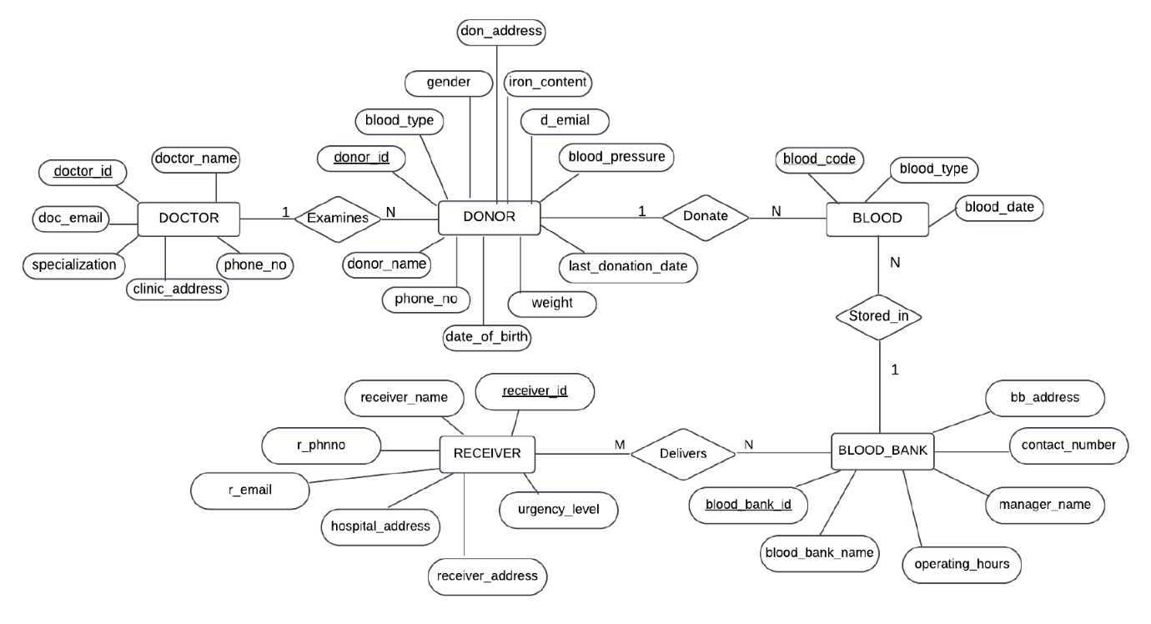

Figure 3.1 ER Diagram

**Chapter 4**

**DETAILED DESIGN**

A Data Flow Diagram (DFD) is a widely used visual tool in system design that illustrates the movement of information within a system. It provides a comprehensive view of how data is processed, stored, and transferred between various entities, ensuring clarity in system requirements. DFDs are instrumental in analyzing both manual and automated processes within a system. They serve as a means to identify data input and output points, process transformations, and storage locations. One of the primary objectives of a DFD is to define the scope and boundaries of a system in a structured manner.

DFDs follow a hierarchical structure, beginning with an overview at Level 0 and progressively detailing more intricate system components in Levels 1 and 2. This hierarchical approach ensures that each layer of the DFD delves deeper into system functionalities, providing a clearer understanding of data interactions and system processes. The diagrams effectively break down the system into manageable segments, allowing developers and analysts to comprehend the flow of information at different levels of granularity.

* 1. 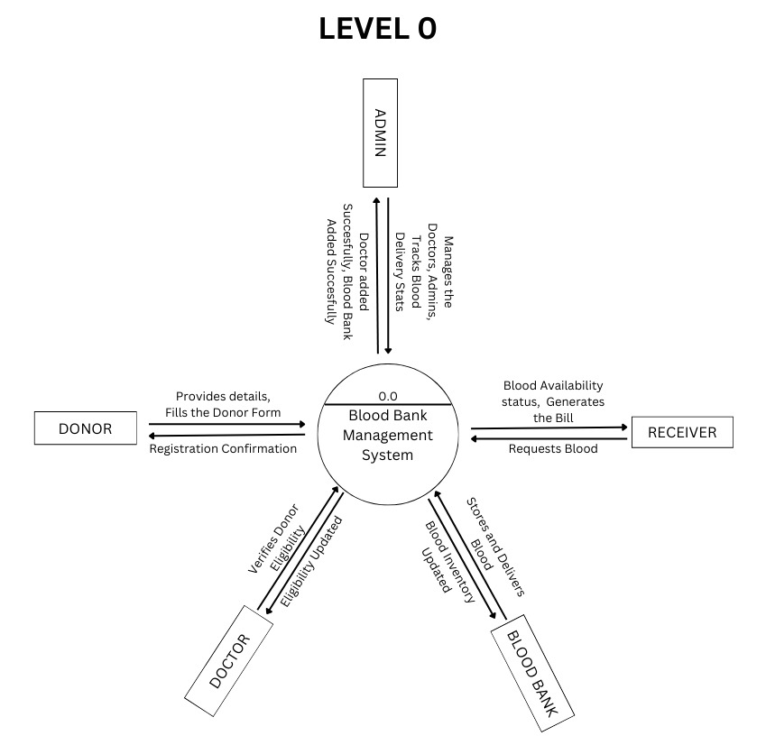**DFD Level 0**

Figure 4.1 DFD Level 0

Fig 4.1, DFD Level 0, often referred to as the context diagram, represents the entire system in a simplified manner. This high-level depiction encapsulates all system requirements within a single process or bubble. External entities, such as users or other systems, interact with the central process, with data flowing in and out as indicated by arrows. In the case of a blood bank management system, the central entity at Level 0 is the Admin, who serves as the main controlling body of the system. All data flow into the Admin entity, and the Admin oversees various operations, including donor examinations, blood donations, and the distribution of blood to receivers. The external entities involved in this process include donors, doctors, and receivers, who interact with the system at different stages. Donors provide blood donations, which are examined and stored by the system. Doctors examine donor blood to determine its usability. Receivers request and retrieve blood from the system when needed. The Level 0 DFD provides a macroscopic view of these interactions, showing how data moves through the system at a high level without delving into specific details.

* 1. **DFD Level 1**

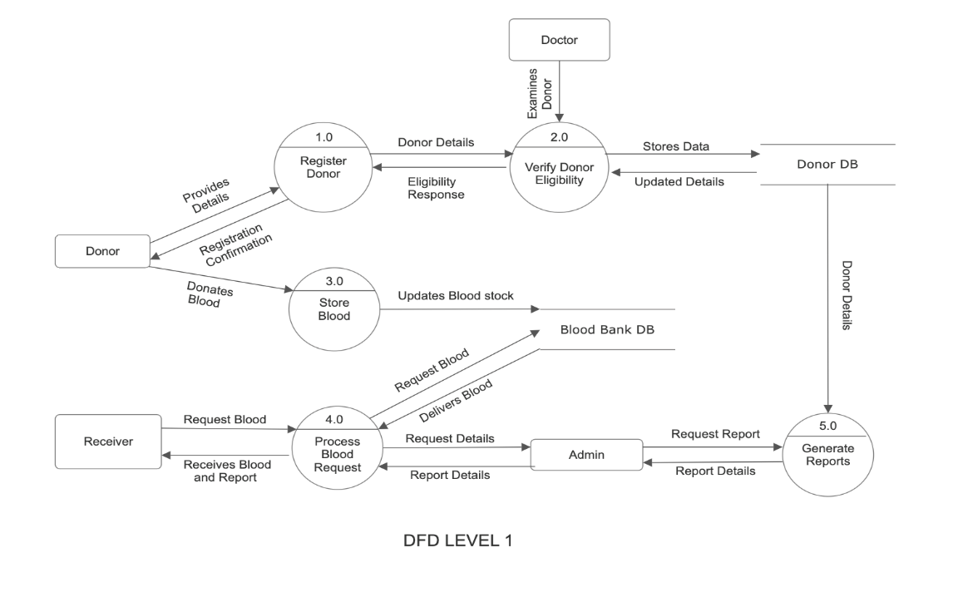

Figure 2 DFD Level 1

Fig 4.1, DFD Level 1, expands on the context diagram by decomposing the primary process into multiple subprocesses. This level provides a more detailed view of the system’s functionality, breaking down high-level operations into individual processes that illustrate how the system achieves its objectives.In the blood bank management system, the key processes at Level 1 are as follows. Before a donation is accepted, a doctor examines the donor's blood to ensure it meets safety and health requirements.

This process involves verifying blood type, checking for infections, and determining if the donor is fit to donate.Once the donor is approved, they proceed with the donation. The system records the blood unit details, including the donor’s information, blood type, and storage location. When a recipient requires blood, they place a request with the Admin. The system checks the available stock and assigns the appropriate blood unit to the receiver, ensuring that the correct type and quantity are provided.Each of these processes is connected with specific data flows, indicating the movement of information within the system. The doctor’s examination process generates a record that updates the system on donor eligibility. The donation process updates the inventory, while the retrieval process ensures blood units are assigned correctly based on recipient needs.

* 1. **DFD Level 2**

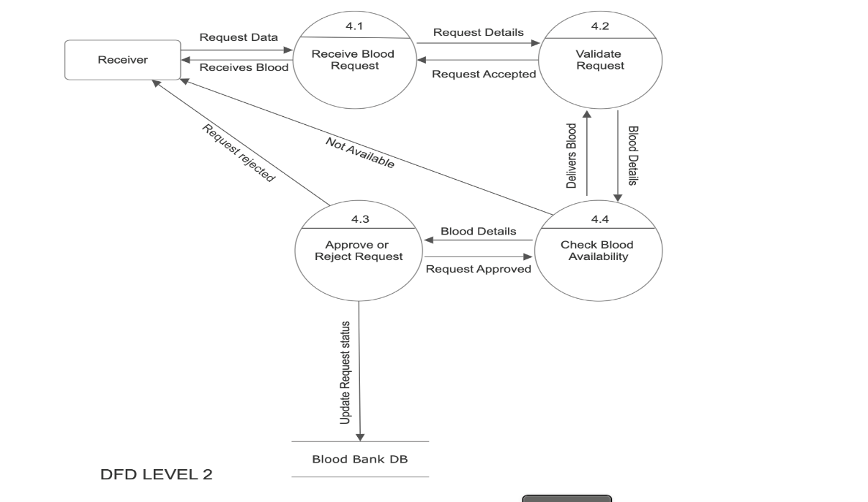

Figure 4.3 DFD Level 2

Figure 4.3 shows DFD level 2, illustrates the detailed workflow of a Blood Bank Management System for processing blood requests. The process begins when the receiver submits a blood request, which is handled in the Receive Blood Request (2.1) phase. The request is then validated in Validate Request (2.2) to ensure its correctness. If the request is accepted, it proceeds to Check Blood Availability (2.3), where the system verifies whether the required blood type is available. If available, the request moves to Approve or Reject Request (2.4), where the final decision is made, and the blood bank database is updated accordingly. If blood is available, the request is approved, and the blood is delivered to the receiver. If it is unavailable, the request is rejected, and the receiver is notified. This process ensures efficient blood request handling and maintains an updated record in the blood bank database.

**Chapter 5**

**RELATIONAL SCHEMA AND NORMALIZATION**

A relational schema is a fundamental component of a relational database, defining the logical structure of how data is stored and related across multiple tables. It acts as a blueprint that specifies the entities, attributes, and relationships within the database. In the Blood Bank Management System, the relational schema ensures that donor, blood bank, doctor, and receiver information is stored efficiently while maintaining data integrity and consistency. Each entity in the schema is represented as a table, where attributes define the characteristics of that entity, and primary keys uniquely identify each record.

For example, the Donor Table contains attributes such as donor_id, donor_name, blood_type, phone_no, and doctor_id, where donor_id serves as the primary key. The doctor_id acts as a foreign key, establishing a relationship with the Doctor Table, which holds attributes like doctor_id, doctor_name, specialization, clinic_address, and phone_no. Similarly, the Blood Table maintains records of blood donations, linking each blood unit to a donor and a blood bank using donor_id and blood_bank_id. The Receiver Table connects recipients to blood banks, ensuring that patients receive the correct blood type from the available inventory.

* 1. 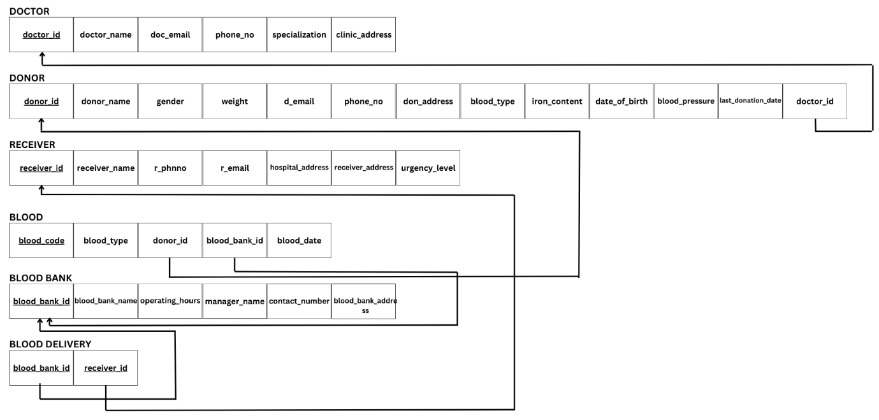**Schema Diagram**

Figure 5.1 Relational Schema Diagram

The Figure 5.1, Relational Schema Diagram visually represents these relationships between entities, using primary keys and foreign keys to establish links. The schema is carefully designed to eliminate data redundancy and optimize database operations. This structured approach allows for efficient data retrieval, modification, and maintenance, ensuring the smooth functioning of the blood bank system.

**Normalization**

Normalization is a systematic approach in database design aimed at organizing data to reduce redundancy, avoid anomalies, and enhance consistency. It involves decomposing complex tables into smaller, well-structured tables that follow specific rules known as normal forms. The primary goal of normalization is to ensure that data dependencies are logically arranged, making the database more flexible and efficient. The process follows multiple stages, namely First Normal Form (1NF), Second Normal Form (2NF), and Third Normal Form (3NF), each eliminating different types of data anomalies.

**First Normal Form (1NF)**

A database table is in First Normal Form (1NF) if all its attributes contain atomic values and do not store multiple values in a single field. In other words, each column should contain values that are indivisible and represent a single data type. Additionally, the table must have a unique identifier (Primary Key) to distinguish each record.In the Blood Bank Management System, all attributes in the database follow 1NF principles because each field holds atomic values without repeating groups or multi-valued attributes. For example, in the Doctor Table, attributes such as doctor_id, doctor_name, doc_email, phone_no, specialization, and clinic_address each store a single value per row. This ensures data consistency and prevents redundancy.

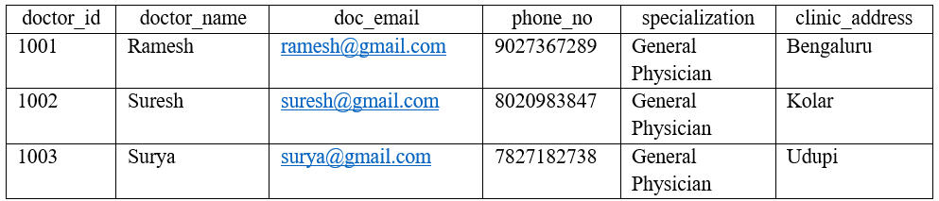Example of a Doctor Table (1NF Compliant)

Figure 5.2 Sample Doctor Data

In the above table, each attribute contains atomic values, meaning a doctor has only one email, one phone number, and one specialization. If multiple specializations were stored in a single row, it would violate 1NF, requiring further restructuring.

**Second Normal Form (2NF)**

A database table is considered to be in Second Normal Form (2NF) when it is already in First Normal Form (1NF) and does not contain partial dependencies, meaning that all non-key attributes are fully dependent on the entire primary key and not just part of it. In a scenario where a table has a composite primary key, a partial dependency occurs when some attributes depend on only a portion of the primary key rather than the full key. To eliminate this issue, such tables must be decomposed into smaller, more structured tables.

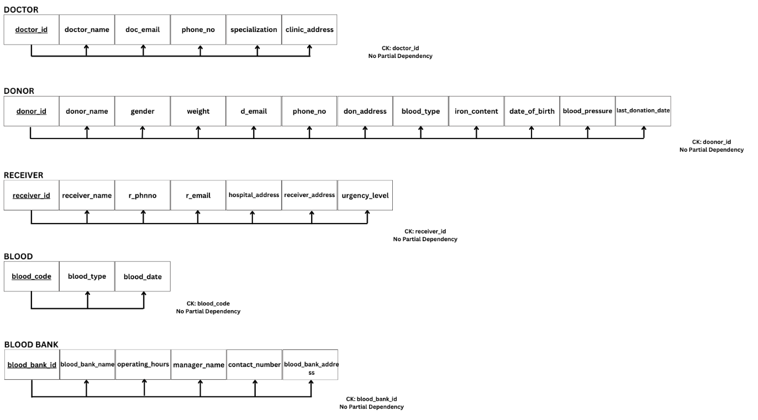In the Blood Bank Management System, consider an initial Blood Donation Table that stores donor details, blood bank details, and the donated blood type. If this table has a composite key consisting of donor_id and blood_bank_id, but attributes like blood_type depend only on donor_id, then a partial dependency exists because blood_type is not functionally dependent on the entire composite key (donor_id, blood_bank_id). To normalize this table into 2NF, we decompose it into two separate tables: one that records Blood Donations with donor_id, blood_bank_id, and donation_date, and another that stores Blood Details, including blood_id, blood_type, quantity, and expiry_date. This restructuring ensures that each non-key attribute is fully functionally dependent on the entire primary key, thereby removing partial dependencies and improving data consistency and integrity.

Figure 5.3 2NF

The Figure 5.1, 2NF Representation visually demonstrates this transformation by showing how a single table with a composite primary key is split into two separate tables to eliminate partial dependencies. The new structure ensures that blood type and related attributes are stored separately, linked by a foreign key, while the donation record maintains relationships between donors and blood banks. This step enhances the database by minimizing redundancy and making queries more efficient, ensuring that modifications in one table do not affect unrelated attributes.

**Third Normal Form (3NF)**

Moving further, a database table reaches Third Normal Form (3NF) when it is already in Second Normal Form (2NF) and contains no transitive dependencies. A transitive dependency occurs when a non-key attribute is indirectly dependent on the primary key via another non-key attribute, rather than having a direct functional dependency on the primary key. This scenario introduces data redundancy and inconsistency, making the database inefficient.

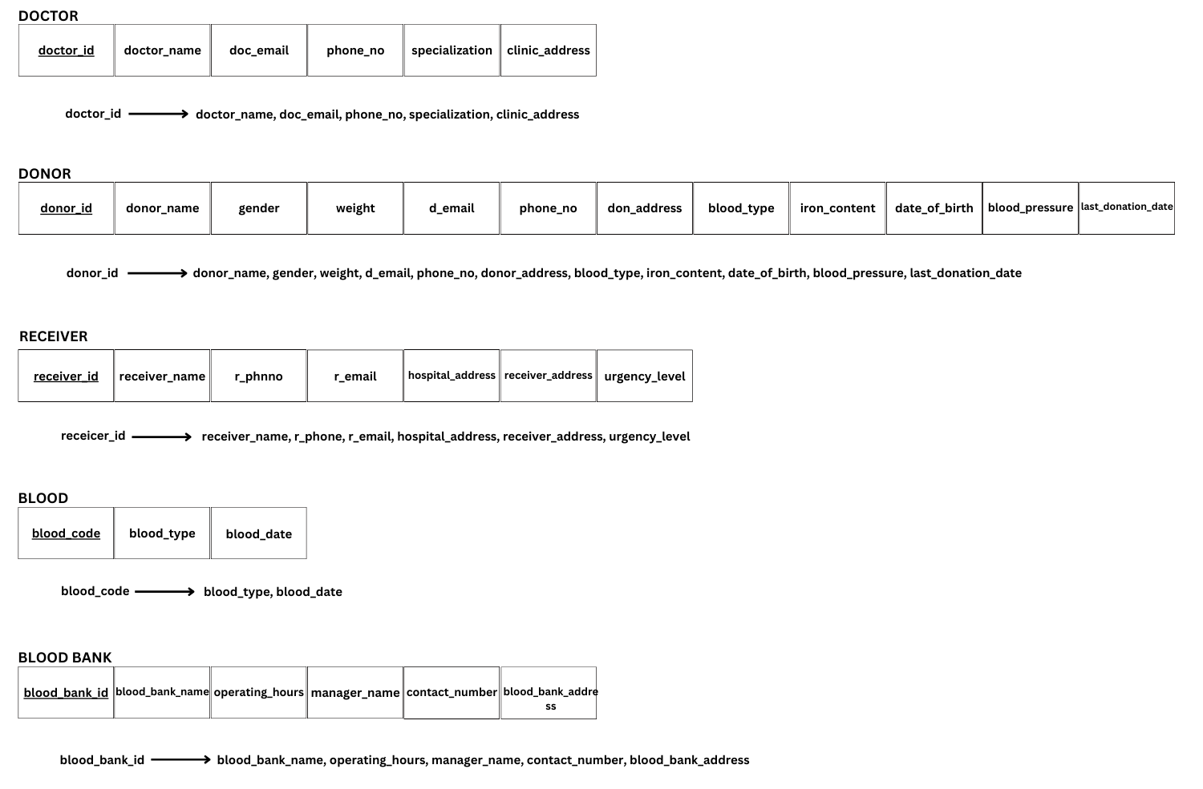For example, in the Blood Bank Table, attributes such as manager_name may be functionally dependent on blood_bank_id, but if manager_contact depends on manager_name instead of blood_bank_id, it creates a transitive dependency. This structure is problematic because if a manager's contact information changes, multiple records need to be updated, leading to possible inconsistencies. To achieve 3NF compliance, we restructure the database by creating a separate Manager Table that stores manager_id, manager_name, manager_contact, and blood_bank_id. This new structure eliminates transitive dependencies, ensuring that every non-key attribute is directly dependent on the primary key, rather than relying on another non-key attribute.

Figure 5.3 3NF

The Figure 5.2, 3NF Representation visually illustrates how breaking the table into separate entities removes transitive dependencies. The revised structure maintains a direct relationship between blood banks and managers, reducing redundancy and ensuring that updates to manager details affect only a single record. This normalization step improves data integrity, consistency, and query performance, ensuring that the database remains efficient and scalable. Through 2NF and 3NF, the Blood Bank Management System achieves a well-structured, highly optimized database that ensures efficient data retrieval, accurate record-keeping, and minimal redundancy, ultimately contributing to better data organization and management.

The Relational Schema and Normalization play a crucial role in the design of the Blood Bank Management System, ensuring that data is organized, efficient, and scalable. The relational schema defines the structure of the database, establishing relationships between entities like donors, doctors, blood banks, and receivers using primary and foreign keys. Normalization further optimizes the database by eliminating redundancy and anomalies, ensuring data integrity and improving query performance.

By applying 1NF, 2NF, and 3NF, the system achieves efficient data storage and retrieval, reducing duplication and inconsistency. The structured approach of normalizing data ensures that updates, deletions, and insertions occur without introducing errors or redundancies. This process ultimately enhances the overall efficiency and reliability of the blood bank management system, enabling smooth data operations and improving the accuracy and integrity of medical records.

**Chapter 6**

**NOSQL**

The Blood Bank Management System is designed to efficiently manage and store critical information related to donors, blood inventory, receivers, and doctors, ensuring fast data retrieval, high availability, and scalability. While traditional relational databases (SQL-based) effectively handle structured data with strong integrity and consistency, modern healthcare applications require the ability to process large volumes of unstructured and semi-structured data. These data types include diagnostic reports, donor health history, and real-time analytics, which are often difficult to manage using rigid tabular structures. To address this challenge, the system incorporates NoSQL (Not Only SQL) databases, specifically MongoDB, to store and process dynamic, hierarchical, and evolving data that does not conform to traditional relational schemas.

A key enhancement in this project is the integration of Natural Language Processing (NLP) for generating concise and meaningful reports on donor health, donation history, and operational analytics. Since these reports are dynamically generated based on medical records, interactions, and donation trends, they require a flexible data storage and retrieval mechanism that relational databases struggle to provide. MongoDB, as a document-based NoSQL database, enables seamless storage of NLP-generated summaries in a JSON-like format, preserving complex relationships and metadata without requiring a rigid schema. This capability makes MongoDB the ideal choice for handling unstructured donor health information, ensuring that the system remains scalable, adaptable, and optimized for real-time decision-making.

Furthermore, the system utilizes an advanced NLP model, specifically mdizak/text-summarizer-bart-large-cnn-samsum-rust, to process medical reports and donor interactions, extracting key insights into blood donations, donor eligibility, and inventory trends. By leveraging machine learning-driven text summarization, the system enhances data-driven decision-making, allowing doctors, administrators, and blood bank managers to quickly review critical health summaries without manually analyzing lengthy reports. This integration of NLP with NoSQL storage not only improves efficiency and accessibility but also ensures that critical donor health information is available in a structured yet flexible format, supporting better resource management and optimized blood transfusion processes.

**Chapter 7**

**CONCLUSION AND FUTURE ENHANCEMENTS**

In conclusion, the Blood Bank Management System represents a significant technological advancement in healthcare data management, offering a robust and efficient framework for handling donor information, blood inventory, and receiver records. By integrating both MySQL and MongoDB, the system achieves a harmonized approach that leverages the relational integrity, consistency, and transactional reliability of MySQL for structured data, while also harnessing the flexibility, scalability, and adaptability of MongoDB for managing unstructured and evolving datasets. This hybrid database architecture ensures that the system remains efficient, scalable, and optimized to handle both structured medical records and unstructured health-related data, making it well-suited for the complex requirements of modern blood bank management.

Beyond basic data storage, the system is designed to enhance operational efficiency through features such as real-time analytics, geospatial querying, and high-availability mechanisms, ensuring accurate tracking, quick retrieval, and dynamic decision-making. The integration of Natural Language Processing (NLP) models further strengthens the system’s capabilities by providing automated summarization of donor health reports, blood donation trends, and inventory status, thereby reducing the workload on medical professionals and improving the efficiency of blood supply management. Overall, the system stands as a testament to the synergy between traditional relational databases and modern NoSQL solutions, delivering a comprehensive, intelligent, and responsive platform that streamlines the entire blood donation and transfusion process. Looking toward the future, there are several key areas where the system can be further enhanced to meet evolving healthcare needs and technological advancements. One of the primary areas of improvement lies in enhancing the user interface and overall user experience. Implementing personalized dashboards, mobile optimization, and interactive data visualization tools would allow users to access, interpret, and manage data more efficiently, improving overall usability for healthcare professionals, blood donors, and administrators. Additionally, enabling seamless mobile compatibility would ensure that real-time blood availability and donor records can be accessed from any device, enhancing accessibility and responsiveness.

Another major enhancement involves the integration of machine learning algorithms to enable predictive analytics for blood demand forecasting, donor retention strategies, and personalized receiver care recommendations. By analyzing historical donation trends, seasonal demand variations, and patient transfusion requirements, the system could proactively predict blood shortages and suggest donation drives at the right time and locations. Additionally, implementing AI-driven donor retention models would help identify inactive donors, recommend personalized reminders, and encourage repeat donations, ultimately improving the overall availability of blood units.

Furthermore, ensuring strong data security and regulatory compliance will be a crucial aspect of future development. Given the sensitive nature of medical and donor information, continuous efforts must be made to enhance encryption mechanisms, implement stricter authentication protocols, and conduct regular security audits. Compliance with healthcare regulations such as HIPAA (Health Insurance Portability and Accountability Act) and GDPR (General Data Protection Regulation) will be essential to maintaining data privacy and trust among users. Advanced blockchain-based record verification could also be explored to enhance the transparency, security, and traceability of blood donations and transfusions.

By continuously fostering innovation, adaptability, and security, the Blood Bank Management System can be refined into an even more intelligent and efficient solution, supporting hospitals, blood banks, and healthcare providers with cutting-edge tools to ensure timely and effective delivery of life-saving blood products. Through ongoing technological advancements and user-driven improvements, the system will play a pivotal role in enhancing healthcare infrastructure, improving patient outcomes, and ensuring the sustainability of blood donation programs for years to come.

**Chapter 8**

**REFERENCES**

[1] **MySQL Documentation**, "MySQL Reference Manual," MySQL, 2024. [Online]. Available: <https://dev.mysql.com/doc/>. [Accessed: 03-Feb-2025].

[2] **MongoDB Documentation**, "MongoDB Manual," MongoDB, 2024. [Online]. Available: <https://www.mongodb.com/docs/>. [Accessed: 03-Feb-2025].

[3] Y. Zhang and M. Lapata, "Neural Text Summarization: A Critical Review," *Transactions of the Association for Computational Linguistics*, vol. 9, pp. 1-24, 2021. [Online]. Available: <https://arxiv.org/abs/2007.03026>. [Accessed: 03-Feb-2025].

[4] J. Han, E. Haihong, G. Le, and J. Du, "Survey on NoSQL Database Technologies," in *Proc. IEEE Int. Conf. Pervasive Comput. Appl.*, Port Elizabeth, South Africa, 2011, pp. 363–366. doi: 10.1109/ICPCA.2011.6106531.

[5] A. Smith and R. Kumar, "Efficient Data Management in Blood Banks Using Hybrid Databases," *J. Med. Informatics*, vol. 27, no. 3, pp. 212-225, 2020.

[6] **HIPAA Journal**, "Data Security in Healthcare," HIPAA Journal, 2024. [Online]. Available: <https://www.hipaajournal.com/>. [Accessed: 03-Feb-2025].

**Chapter 9**

**APPENDIX**

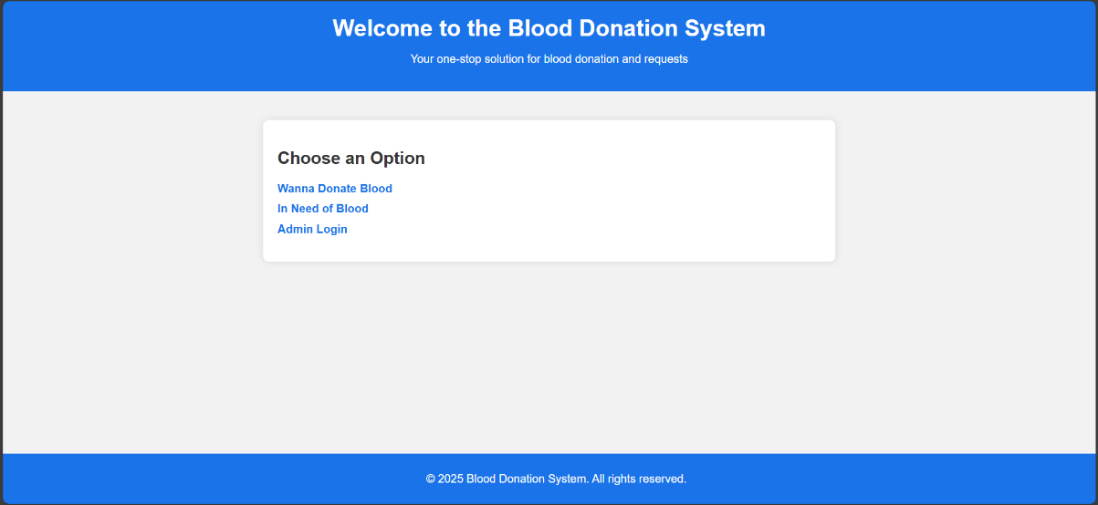**Screenshots with descriptions**

Figure 9.1 Homepage

Figure 9.1 shows the **Home Page** of the website where there are options to **donate blood**, **request blood** and for **admin login** to add doctors and blood banks.

Figure 9.2 shows the **Donor Form** of the Blood Donation System, designed to collect detailed donor information. It includes fields for personal details, medical history, blood type, and donation specifics. The form ensures comprehensive data collection.

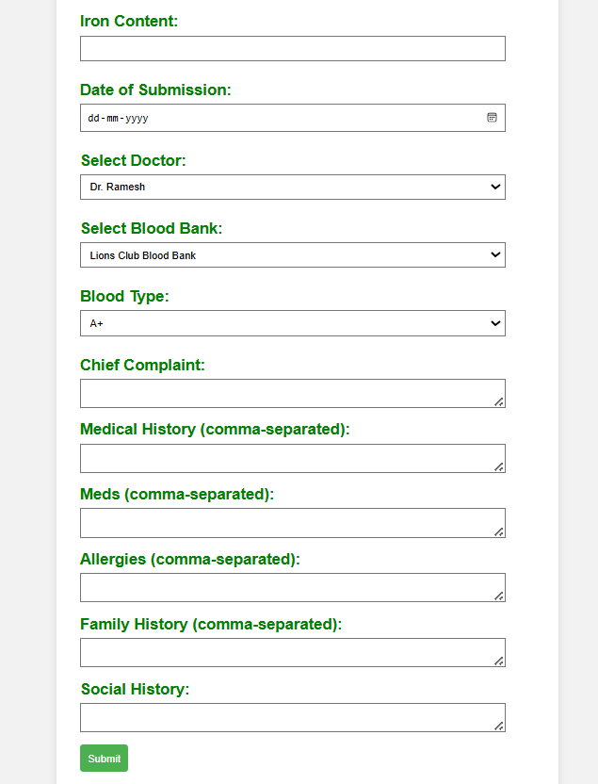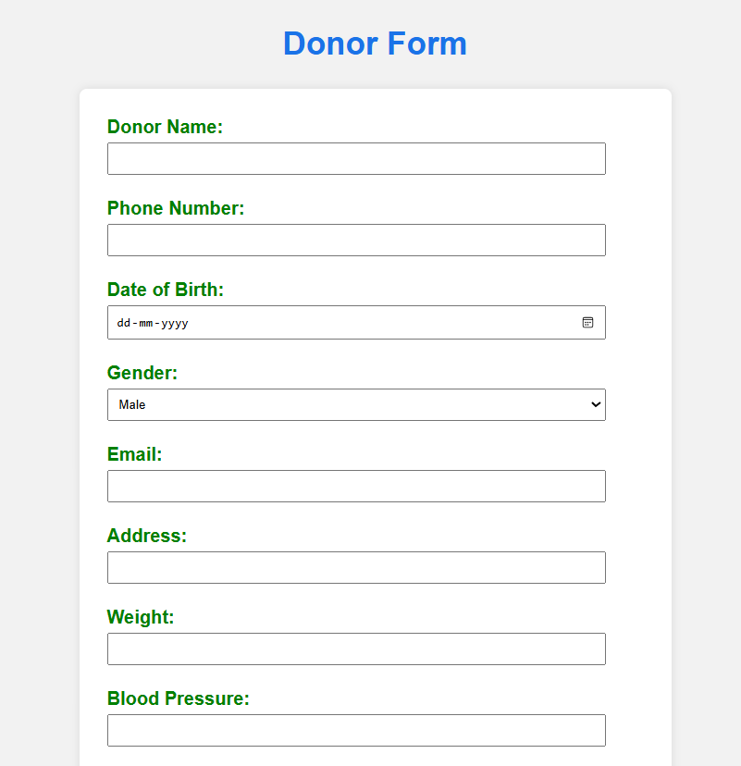

Figure 9.2 Donor Registration

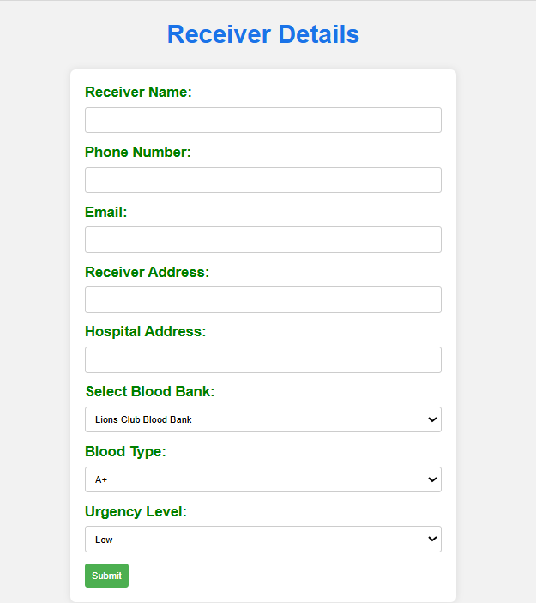

Figure 9.3 Receiver Details

Figure 9.3 displays the **Receiver Details** form, which is used to collect information from individuals requesting blood. The form includes fields for the receiver's name, phone number, email, address, hospital address, selected blood bank, blood type, and urgency level.

Figure 9.4 Admin Page

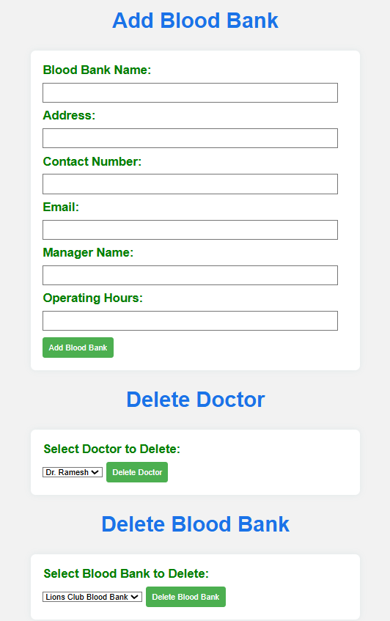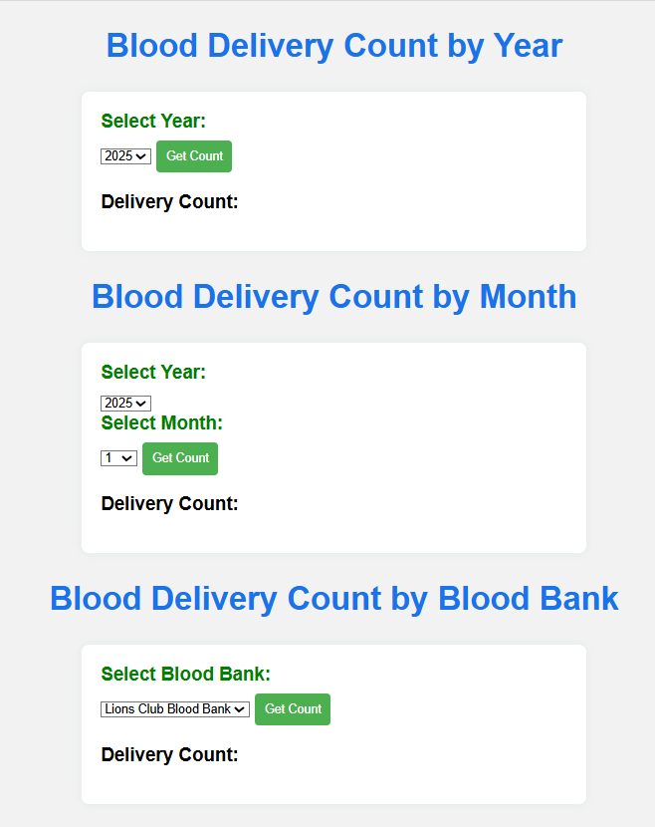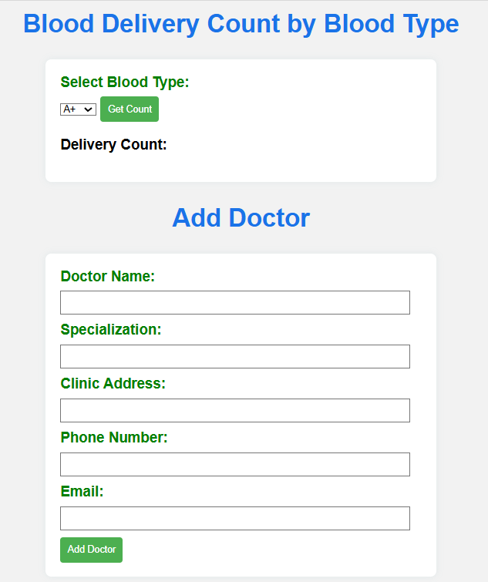

Figure 9.4 shows the admin panel for managing blood banks, doctors, and blood delivery records. It includes sections to track blood delivery counts by year, month, blood bank, and blood type. Admins can add or delete blood banks and doctors using dedicated forms. This interface ensures efficient management of key operations in the blood bank system.

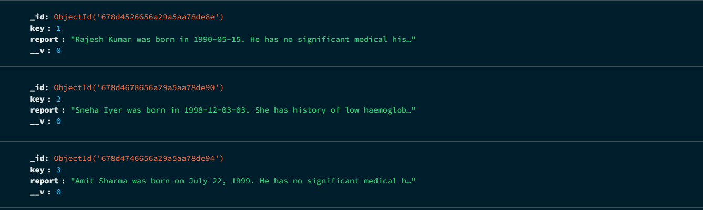

Figure 9.5 Summarized Donor Details in MongoDB

Figure 9.5 represents how donor details are stored in **MongoDB**, a **NoSQL database**. The system uses an **NLP model from Hugging Face** to summarize the donor's provided medical details before saving them. Each record includes a unique ID, a key, and a summarized report, ensuring efficient storage and quick retrieval of donor information.